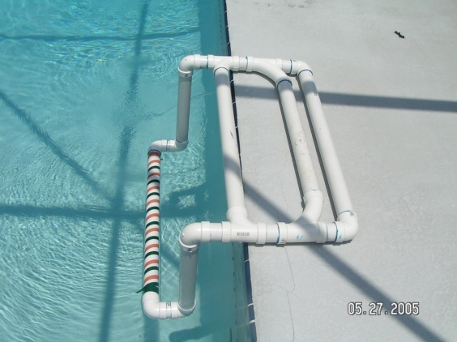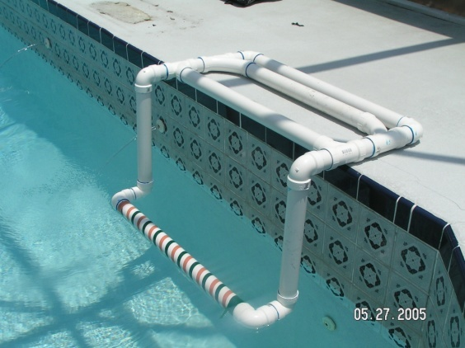

The length across the deck is 33&½ inches. The length going towards the pool in 24 inches. After you measure the depth into your pool the bar should be about 6 inches from the wall. You can use any size PVC piping and fill the part that stays on the deck with play sand, crushed stone or rock whichever you prefer. You can cap it off in the tube with foam insulation (be careful very messy and expands quickly). We suggest the blue colored PVC glue because it is made to be submerged. If when you get it in the water & the child leans on it, place a bag of play sand that is wrapped in a garbage bag (incase the original bag breaks) across the top.

